Name ________________________ HOMEWORK Nov. 14-18
Module 4 Week 1
Put your initials by each night that your child practiced the following:
____ Monday ____Tuesday ____Thursday
*Nightly Homework*
1. Count numbers 1-50.
2. Practice assigned Sight Word list in red reading folder.
MONDAY-Identify initial sounds. Circle the picture that has the same beginning sound as the given picture?

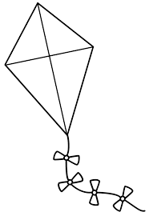  kite | 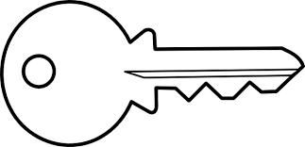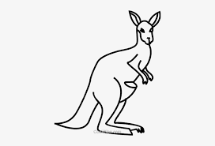  king mug key kangaroo truck
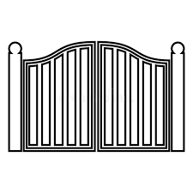  gate | 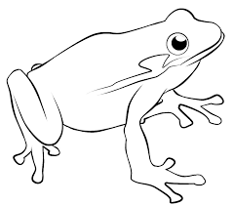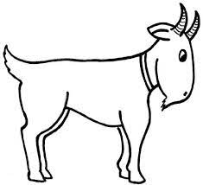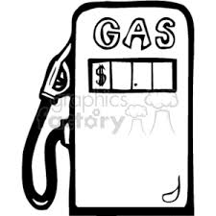  frog goat car gas ghost

Circle the words that ends with the /g/ sound with a blue crayon and the words that end with the /k/ sound with a green crayon.
rug leg stick fog pink pig

wag duck sock black dig bug
TUESDAY- Trace and practice forming the letters.
G g G g G g ______
K k K k K k ______
Read it. Trace it. Write it.
pat pat ____
tap tap ____
cap cap ____

THURSDAY- Identify initial sounds. Color the happy face if the pictures begin with the same sound. Color the sad face if the words do not begin with the same sound.

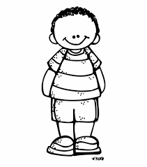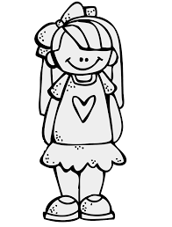
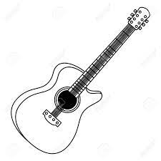
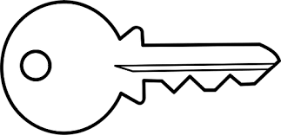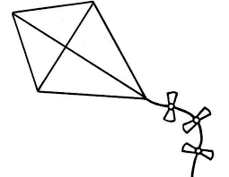

Start Right Reader Module 4 Week 1
Words to Know
very
his
good

Kip
Nan rips a bag and tips it in. Kip nags Nan. “No, Kip! Sit!” “Dig in, Kim!” Kim has a bit. “Very good, Nan!” Kip nags Kim. “Sit, Kip!” Nan has a bit. Kips nips at it. “No, Kip! Sit!” “Kip!”
Kim tips a bit in his pan.
“Dig in, Kip!”

